**Phase Factor – Functional Decomposition**

**ECEN 4620**

**FD0**

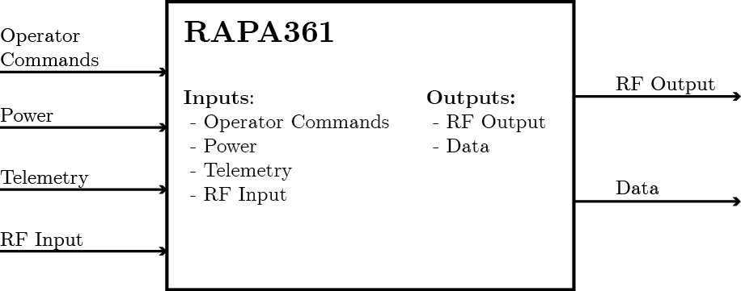

|  |  |
| --- | --- |
| **Module** | Radio Agnostic Phased Array |
| **Inputs** | * Operator Commands – On/Off, modes of operation, data to be sent to drone * Power – power over Ethernet or from external batteries * Telemetry – Information on the location of the drone * RF Input – Received RF input from the drone |
| **Outputs** | * RF Output – generic RF data sent to drone * Data – Interpreted data from drone to be sent to user. Also includes system status information |
| **Functionality** | Radio agnostic phased array designed to interface with one or more mobile UAVs. It serves as a data pipe from the user to a generic user provided radio, and connects to the UAV via the phased array system. It can be switched from power over Ethernet to power from external batteries, depending on the application. |

**FD1**

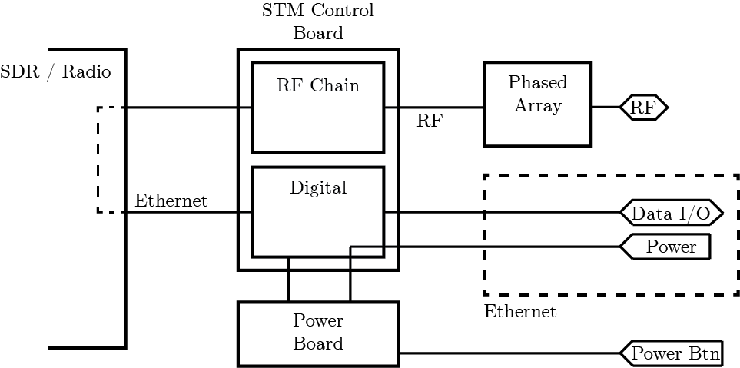

|  |  |
| --- | --- |
| **Module** | Phased Array |
| **Inputs** | Tx: phase and amplitude adjusted RF signal  Rx: RF signal from the UAV |
| **Outputs** | Tx: RF signal sent to the UAV  Rx: received RF signal to RF adjustment chain |
| **Functionality** | The phased array is an antenna. It will either send or receive a RF signal directionally, depending on how the phase shifters and attenuators are set in the RF chain. |

|  |  |
| --- | --- |
| **Module** | RF Chain |
| **Inputs** | Tx: Raw RF information from Radio  Rx: received signal from the phased array |
| **Outputs** | Tx: Phase/amplitude adjusted signal for the array  Rx: Reconstructed signal sent to SDR |
| **Functionality** | The RF Chain is what, in concert with the phased array elements, allows for the RF signal to be steered. The RF Chain is responsible for doing phase adjustment and amplitude attenuation. |

|  |  |
| --- | --- |
| **Module** | Digital |
| **Inputs** | Power will be passed to this system (via Ethernet)  Tx: Ethernet data from the user, containing information to send  Rx: Decoded information from the SDR |
| **Outputs** | The power received from the Ethernet will be passed to the power board  Tx: Set the RF chain to send the signal in the correct direction, and push information to the SDR  Rx: Make sure the RF chain is directed correctly to receive, and push received information to the user |
| **Functionality** | The digital board is the brains of the entire system. It is responsible for handling pointing/tracking using the RF chain, as well as interpreting incoming and outgoing packets, and pushing them to the correct places. It also handles any inputs from the user for system control, not related to the RF system. |

|  |  |
| --- | --- |
| **Module** | SDR/Radio |
| **Inputs** | Tx: Ethernet data from the Digital board  Rx: RF signal from the RF chain |
| **Outputs** | Tx: Interpreted digital signal turned into associated RF signal  Rx: The digital signal decoded from the RF input |
| **Functionality** | The SDR (software defined radio) is capable of translating digital commands into RF signals, and vice versa. This is going to be provided by the user, and the rest of the system should not be dependent on the inner workings of the radio. We will likely be using a radio from XetaWave for proof of concept. |

|  |  |
| --- | --- |
| **Module** | Power Board |
| **Inputs** | Power from the STM control board (contains both the RF Chain and Digital system) |
| **Outputs** | Power rails required by the rest of the system |
| **Functionality** | This board is intended to take in the raw power given to us over the Ethernet connection, and clean it up and convert it as necessary for the rest of our systems. |